**Research Notes**

Week 3, 14/03/2021

* Found a possible API called “TripIt” which could be utilised into our app which possesses many of the functionality of a trip planner.
  + We will take the trip planning functionalities from this API and integrate it into our app
* 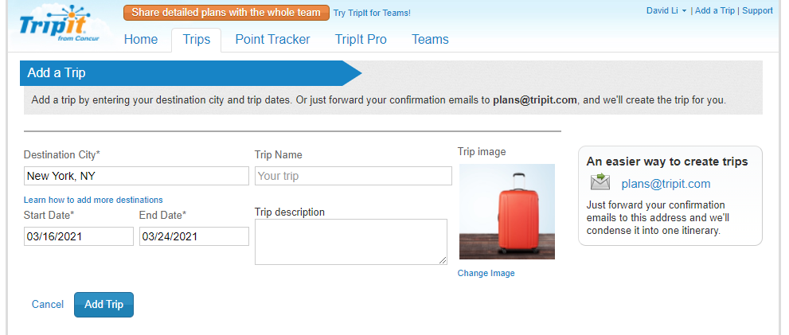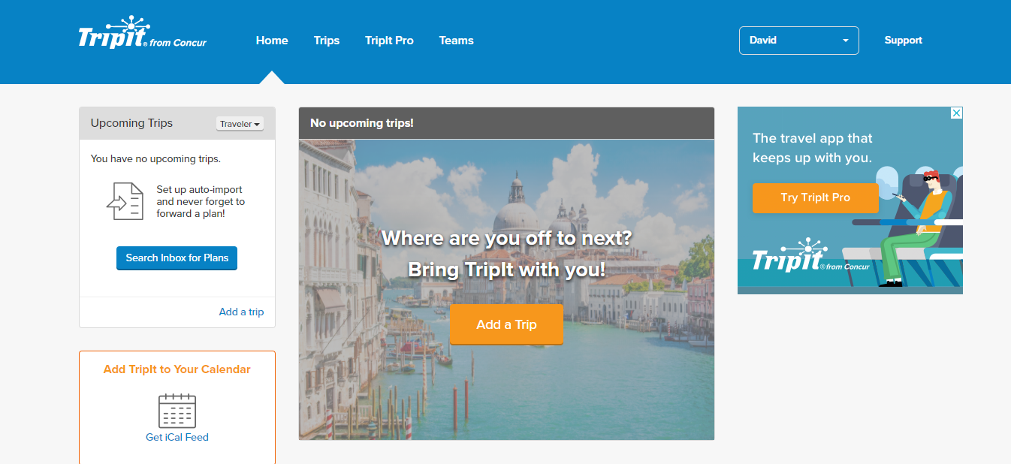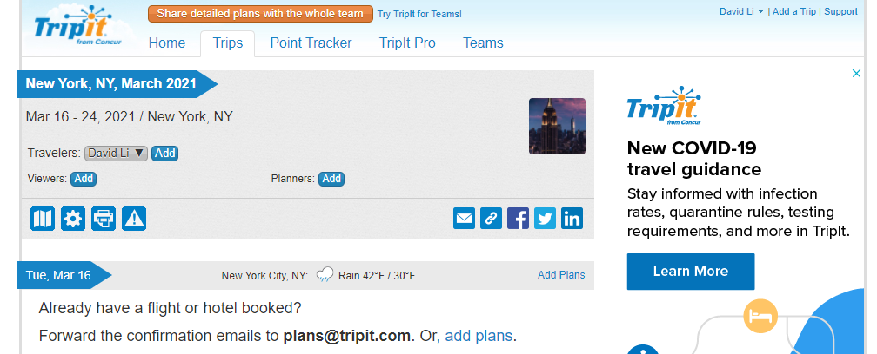It was discussed in this week’s meeting, and instead of reinventing the wheel, we will try to take what already works and focus on the features which are most important to the project.